Code-A-Pillar Math

MGSE1.OA.6 (Add and subtract within 20)
E.Q.: How can we add numbers to 20?
Objective: Students will program their Code-A-Pillar to roll to the correct answer to the problem.
Materials:
- Code-A-Pillar (1 per group. 4 to 5 students in a group)
- Large piece of butcher paper draw a large circle on it with one answer on one section and another on the other
- Math teacher made task cards (15-20 various addition/subtraction for 1st grade or 15-20 picture number cards for kindergarten) I used problem that would have on two answer options
Procedures:
Mini Lesson
- Model how to start Code-A-Pillar and add pieces to it.
- Model using the Code-A-Pillar to travel a distance in the room by adding a straight, left and right piece and demonstrating how it works
- Show an addition Task Card, and explain that they must solve the problem then program the Code-A-Pillar to drive in the direction of the answer.
Group Task
- Students will receive a math task card. They must first decide on an answer to the problem then program the robot to drive to the answer.
- Students will keep the card if they got the answer right.
- At the end students will count the number of cards they have collected.
Conclusion
- Ask the students to discuss their strategy for finding the answer and programming the robot.
Assessment
Informal Observations will be recorded by the teacher

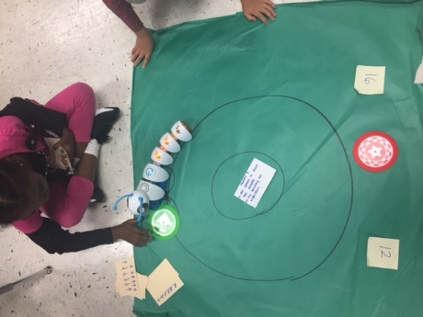
9 + 3 = | 8 + 8 =
11 + 1 = | 10 + 6 =
8 + 4 = | 14 + 2 =
6 + 6 = | 4 + 12 =
5 + 7 = | 1 + 15 =
10 -5 = |  | 14 -7 =
12 – 7 = |  | 19 – 12 =
8 – 3 = |  | 9 – 2 =
14 – 9 = |  | 11- 4 =
9 -4 = |  | 10 -3 =

